SQL:

Exercise 1:

Customer table:

CREATE TABLE Customers (

    CustomerID   NUMBER PRIMARY KEY,

    Name         VARCHAR2(100),

    Age          NUMBER,

    Balance      NUMBER(10, 2),

    IsVIP        VARCHAR2(5)

);

Loan table:

CREATE TABLE Loans (

    LoanID       NUMBER PRIMARY KEY,

    CustomerID   NUMBER REFERENCES Customers(CustomerID),

    InterestRate NUMBER(5, 2),

    DueDate      DATE

);

Insertion of sample data:

Into Customers table:

INSERT INTO Customers VALUES (1, 'Alice', 65, 12000, 'FALSE');

INSERT INTO Customers VALUES (2, 'Bob', 45, 9000, 'FALSE');

INSERT INTO Customers VALUES (3, 'Charlie', 70, 11000, 'FALSE');

INSERT INTO Customers VALUES (4, 'Diana', 30, 10500, 'FALSE');

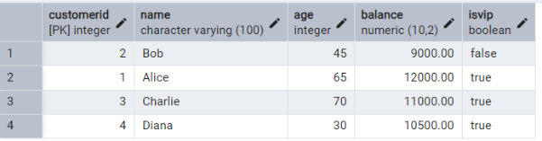

Into Loans table:

INSERT INTO Loans VALUES (101, 1, 8.5, SYSDATE + 10);

INSERT INTO Loans VALUES (102, 2, 9.0, SYSDATE + 40);

INSERT INTO Loans VALUES (103, 3, 10.0, SYSDATE + 5);

INSERT INTO Loans VALUES (104, 4, 8.0, SYSDATE + 25);

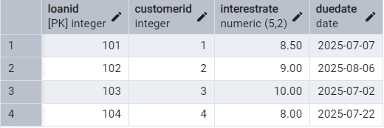

COMMIT;

Scenario 1: Apply 1% Discount for Age > 60

BEGIN

  FOR cust_rec IN (SELECT CustomerID FROM Customers WHERE Age > 60) LOOP

    UPDATE Loans

    SET InterestRate = InterestRate - 1

    WHERE CustomerID = cust_rec.CustomerID;

  END LOOP;

  COMMIT;

END;

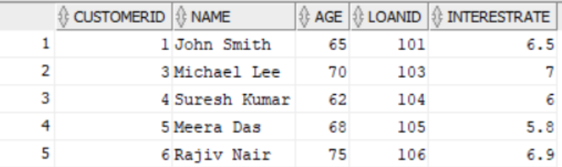

Scenario 2: Promote to VIP if Balance > $10,000

BEGIN

  FOR cust_rec IN (SELECT CustomerID, Balance FROM Customers) LOOP

    IF cust_rec.Balance > 10000 THEN

      UPDATE Customers

      SET IsVIP = 'TRUE'

      WHERE CustomerID = cust_rec.CustomerID;

    END IF;

  END LOOP;

  COMMIT;

END;

Scenario 3: Send Reminders for Loans Due in Next 30 Days

SET SERVEROUTPUT ON;

BEGIN

  FOR loan_rec IN (

    SELECT L.LoanID, C.Name, L.DueDate

    FROM Loans L

    JOIN Customers C ON L.CustomerID = C.CustomerID

    WHERE L.DueDate BETWEEN SYSDATE AND SYSDATE + 30

  ) LOOP

    DBMS_OUTPUT.PUT_LINE('Reminder: Loan ID ' || loan_rec.LoanID ||

                         ' for customer ' || loan_rec.Name ||

                         ' is due on ' || TO_CHAR(loan_rec.DueDate, 'DD-MON-YYYY'));

  END LOOP;

END;

# 